**Experiment No :** 05

**Experiment name :** write a C program for bubble sort (Ascending or Descending order )

**Methodology :**

We know the rule of bubble sort is that the smallest number among the numbers in the same serial is brought first, see how it comes if it is 10 5 11 8 7 If there are some numbers like this then first compare 10 and 5 and 10 will leave in place of 5 will be taken. Similarly, it will compare with other numbers in the same way, in this way it will compare with all the numbers and arrange them in accnding and dcccnding form.

**Flow-Chart :**

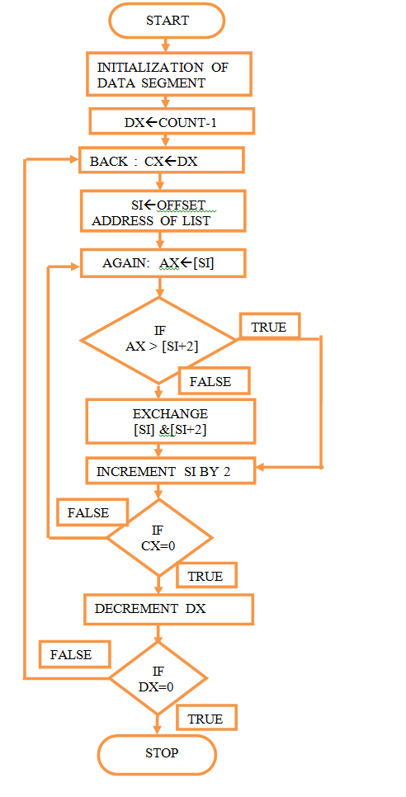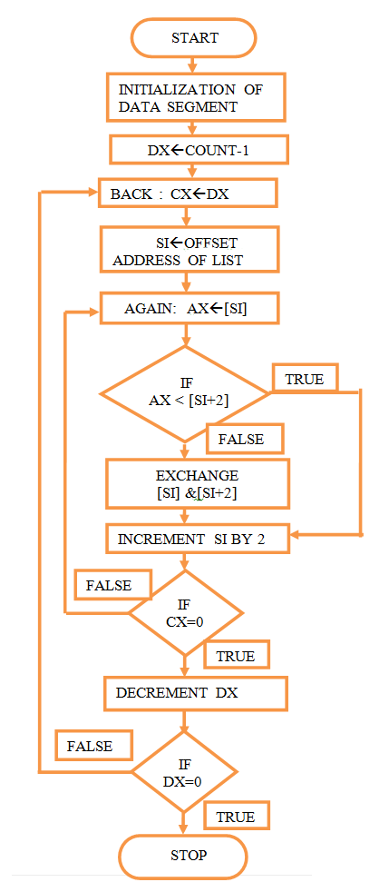

**Code :**

#include<stdio.h>

int main()

{

int array[100] , num , c , d , swap ;

printf("Enter number of elements : ");

scanf("%d",&num);

printf("Enter %d integers\n",num);

for(c=0 ; c<num ; c++){

scanf("%d",&array[c]);

}

for(c=0; c<(num-1) ;c++){

for(d=0;d<num-c-1 ; d++){

if(array[d] > array[d+1]){

swap = array[d];

array[d] = array[d+1];

array[d+1] = swap ;

}

}

}

printf("Shorted list in ascending order :\n");

for(c=0 ; c<num; c++){

printf("%d\n",array[c]);

}

printf("\nSorterd list in descending order:\n");

for(c=num-1 ; c>=0 ; c--){

printf("%d\n",array[c]);

}

return 0;

}

**Output:**

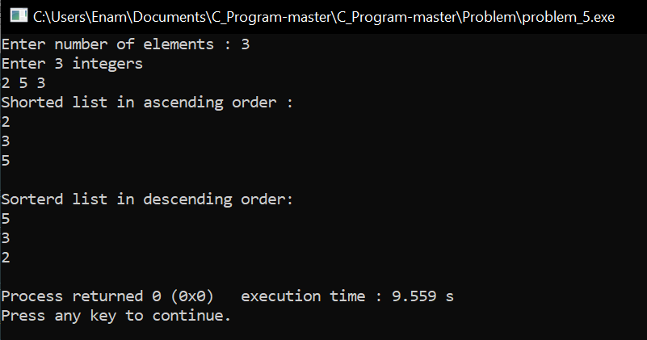

**Result discussion :**

In this program through babul short we have taken numbers from some user and we have printed those numbers in ascending and descending order, in our mathology we have seen how babul shot works, we have written this program using those maths in our program.